1. List employee number, last name, first name, sex and salary.

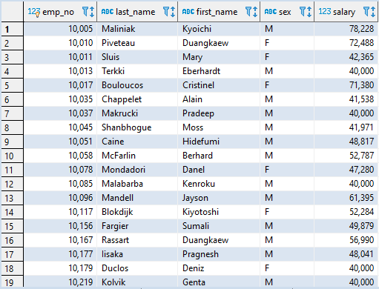

1. List first name, last name, and hire date for employees hired in 1986.

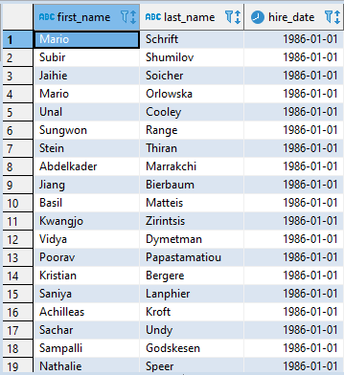

1. List manager department number, department name, manager employee number, last name and first name.

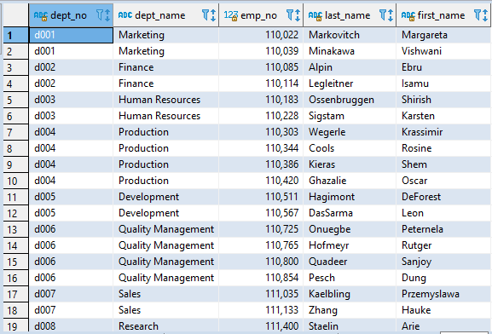

1. List department of each employee with employee number, last name, first name and department name.

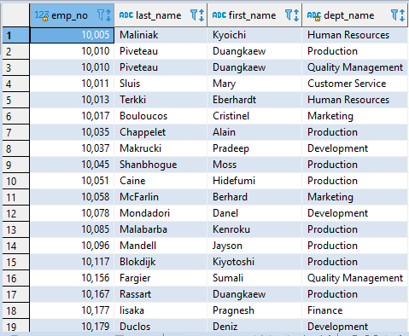

1. List first name, last name and sex for employees whose first name is "Hercules" and last names begin with "B".

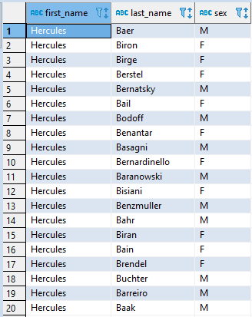

1. List employees in Sales department, including their employee number, last name, first name, and department.

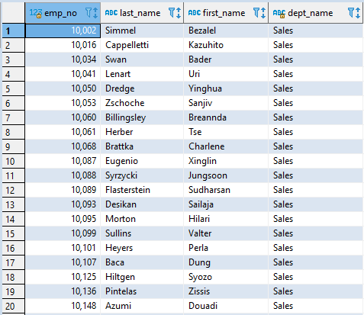

1. List all employees in Sales and Development departments, including employee number, last name, first name, and department name.

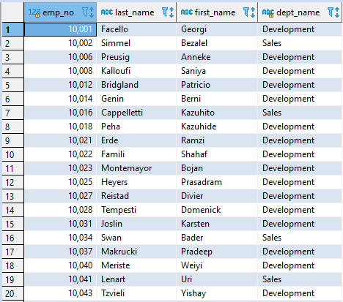

1. List frequency count of employee last names in descending order.

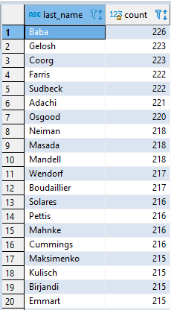

ERD Graph

